 | 12.1.10 Editors - Geometry Nodes Editor - Header - Add Menu - Output
Table of content
Detailed table of content 1
Add menu - Output 1
Viewer 1
Warning 2

Detailed table of content
Detailed table of content
Detailed table of content 1
Add menu - Output 1
Viewer 1
Inputs 1
Geometry 1
Warning 2
Inputs 2
Show 2
String 2
Properties 2
Warning type 2
Output 2
Output 2

Add menu - Output

Here you find nodes that outputs data.

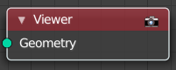
Viewer
This node allows you to output the geometry data of a node in the node tree to the spreadsheet editor.

Inputs

Geometry
Standard geometry input.

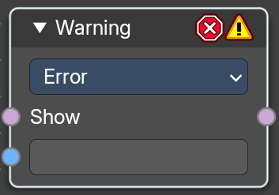
Warning
Allows node groups to throw expectations.

Inputs

Show
Is true or false.

String
The string to show at evaluation.

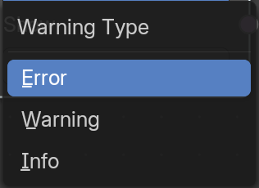
Properties

Warning type
What type the warning should be.

Output

Output
Output the warning string if true.

